Loanalytic- Web

Software Requirements Specification

Version- 1.1

Date- 6/13/2019

Team Members

Gangadhar Adusumalli

Vamsee Krishna Gangapatnam

Keerthi Sree Kukunoor

Gouthami Pasham

Taraka Raviteja Peddi

Himabindu Poshala

Meghana Putta

Submitted in partial fulfillment

Of the requirements of

CSIS 44-691 Graduate Directed Project 1

# Revision History

|  |  |  |  |
| --- | --- | --- | --- |
| **Date** | **Description** | **Author** | **Comments** |
| 6/11/2019 | Version 1 | Gouthami Pasham | First Revision |
| 6/13/2019 | Version 1.1 | Himabindu Poshala | Second Revision |
|  |  |  |  |
|  |  |  |  |

# Document Approval

The following Software Requirements Specification has been accepted and approved by the following:

|  |  |  |  |
| --- | --- | --- | --- |
| **Signature** | **Printed Name** | **Title** | **Date** |
|  |  |  |  |
|  |  |  |  |
|  |  |  |  |

Table of Contents

1. Introduction 5

1.1 Purpose 5

1.2 Scope 5

1.3 Definitions, Acronyms, and Abbreviations 5

1.4 References 5

1.5 Overview 5

2. General Description 5

2.1 Product Perspective 5

2.2 Product Functions 5

2.3 User Characteristics 5

2.4 General Constraints 5

2.5 Assumptions and Dependencies 5

3. Specific Requirements 5

3.1 External Interface Requirements 5

3.1.1 User Interfaces 5

3.1.2 Hardware Interfaces 5

3.1.3 Software Interfaces 5

3.1.4 Communications Interface 5

3.2 Functional Requirements 5

3.3 Use Cases 5

3.4 Class/Objects 5

3.5 Non-Functional Requirements 5

3.5.1 Performance 5

3.5.2 Reliability 5

3.5.3 Availability 5

3.5.4 Security 6

3.5.5 Portability 6

3.6 Inverse Requirements 6

3.7 Design Constraints 6

3.8 Logical Database Requirements 6

3.9 Other Requirements 6

3.10 Prototypes (for complete project) 6

3.11 Use Case Diagrams 6

4. Design 6

4.1 ER diagram 6

4.2 GUI 6

5. Analysis Models 6

5.1 Data Flow Diagram 6

5.2 Sequence Diagram 6

1. **Introduction**

**1.1 Purpose**

The purpose of this document is to build an online application- Loanalytic-Web for bank loans.

**1.2 Scope**

The purpose of Loanalytic-Web is to make the life of the borrower easy by simply registering to an online portal and get a loan approval. The application deals with 3 kinds of loans: Mortgage, Personal and Education loan. The user can quickly choose the kind of loan he wants and the amount he wants to borrow. Loan request would be validated by the application automatically as soon as the user answers few questions based on the kind of loan. The feasibility of loan approval would be displayed immediately. If the criteria is not met the user would be notified immediately else a background check is performed by the admin and a manual notification is sent by the admin. The application gives an opportunity to the admin to verify the user by validating the documents he has uploaded and doing some criminal/background check. Above all, we hope to provide a comfortable user experience along with the best pricing available.

**1.3 Definitions, Acronyms, and Abbreviations**

The following are the conventions used in the document:

* DB- Database
* ER- Entity Relationship
* IR- Interest Rate

**1.4 References:**

<https://www.quickenloans.com/l/progpi?gclid=Cj0KCQjwov3nBRDFARIsANgsdoEDTTowesJOqC8EQObf-jTuhdo9wy0lBS3gTbXcclNhE1gf7NtrIB8aArynEALw_wcB&qls=GAW_LNPREAPe.0000714218&ef_id=Cj0KCQjwov3nBRDFARIsANgsdoEDTTowesJOqC8EQObf-jTuhdo9wy0lBS3gTbXcclNhE1gf7NtrIB8aArynEALw_wcB:G:s&s_kwcid=AL!1083!3!43582782849!e!!g!!loan%20approval&gclsrc=aw.ds>

**1.5 Overview:**

1. **General Description**

**2.1 Product Perspective:**

This application enables the user to work with the bank virtually to find all the information to get the loan and gets his loan approved even without visiting the bank. The user need not travel to the bank to get his loan. The user can choose among various options available to him using the calculator available in the application.

**2.2 Product Functions:**

The application has two modes, the user mode and the Admin mode.

**User can perform all the below operations:**

* Register and login into the application.
* Change the password.
* Choose the kind of loan from the dropdown.
* Choose the amount he wants to borrow.
* Answer all the questions related to Eligibility criteria and background/criminal history verification.
* Choose the Credit score.
* Able to apply by submitting the required information and documents.
* Chat with customer support in case of any questions.
* Access the frequently asked questions document.
* Use the Loan Calculator to find the interest amount for various time periods and amounts.
* Ability to choose the Payment methods.
* Give a rating to the organization for their service.
* Able to view the status of their applications.

**Admin Can perform the below Operations:**

* Able to login to the website
* Able to add different categories of loans with requirements.
* View all the applications.
* View documents provided by the users.
* Manage users.
* Approve and reject loans
* Able to process loan and update status of loan applications.
* Count of application.
* Generate reports to view the customer payment history and more.

**2.3 User Characteristics:**

This application is used by any users who wish to borrow amount for his immediate use.

**2.4 General Constraints:**

Cannot think of any as of now.

**2.5 Assumptions and Dependencies:**

All the developers have good understanding of the technology.

The project should be completed end of December, 2019.

1. **Specific Requirements**

**3.1 External Interface Requirements**

**3.1.1 User Interfaces**

The UI is developed using angular.

**3.1.2 Hardware Interfaces**

**3.1.3 Software Interfaces**

* Angular to develop the GUI
* MySQL database to store the data
* Plotly for generating reports.
* Heroku to host the application online.

**3.1.4 Communications Interface**

We can use email and chat box as a communicating interface.

**3.2 Functional Requirements:**

**Home page:**

* 1. This page contains a navigation bar having “chat” symbol, “sign in” and contact information.
  2. A simple dropdown with 3 options is available in the body of the home page.
  3. The 3 options in the dropdown are:
* Mortgage Loan
* Personal Loan
* Education Loan
  1. A Next button is available to navigate to the next page. Here a validation check should be performed. The user should not be allowed to navigate to the next page unless he chooses one of the option as listed above.
  2. User credit rating score should be displayed in the dropdown, allowing the user to choose a credit range. A next button and a back button is also available in same page allowing the user to navigate to the next page and previous page respectively. The user cannot navigate to the next page unless he choose his credit rating. User can navigate to the previous page irrespective of the option chosen or not chosen from the drop down.

These are the credit rating available in the dropdown:

* Low
* Below Average
* Average
* Above Average
* Good Excellent
  1. User is asked questions based on different loans and is allowed to choose the period of repayment.
  2. Based on the repayment period, the total amount to be payed, the interval and the complete summary of the loan is displayed on the page along with an Accept button, back button and cancel button.
  3. If the cancel button is clicked the application should display the initial page.
  4. If the back button is clicked, navigate to the previous page.
  5. The user can click on accept button, if he likes the quote. If the users clicks on Accept he is asked few questions to register or login into the application. Register or login into the application to upload few documents. 2 attachments to upload the documents, next and back button should be provided.

Here is the list of document the user is asked to upload:

* Previous 3 months pay slips
* Id proofs
  1. Clicking on the next should give a notification to the user, conforming the application is filled and an email should be sent to the user.
  2. There is a chat button available in the navigation bar. It has to open the chat box and allow the user to talk to the admin in case of any questions.
  3. There is a sign in button available on the navigation bar. Clicking on the sign in button allows the user or admin to log in into the application.
  4. If the user logs in, the status of his application and the previous application history should be displayed. This page should also have a button which should redirect to the step 2.
  5. If the admin logs in, he can view various options in the body of the page:
* View applications.
* Create new loans.
* View the trend of the payments.
  1. The Admin can view each application, access all the documents uploaded by the user and approve/reject the application accordingly.
  2. The admin has the ability to send an email to the user from the application.

**Signup/Sign in Page:** This allows the user or admin to log in into the application.

**Forgot Password:** This allows the user to change the password. The link to change the password should be sent to his email id provided during registration.

**3.3 Use Cases:**

**3.4 Class/Objects:**

**3.5 Non-Functional Requirements**

### 3.5.1 Performance:

Using data optimization techniques to retrieve the data quickly.

### 3.5.2 Reliability

Ensure to use ACID rules while designing the database, thereby making reliable system.

### 3.5.3 Availability:

### Hosting the application on cloud to ensure it’s available to the user all the time.

### 3.5.4 Security:

The info provided by the user is secure and would not be shared to anyone.

### 3.5.5 Portability:

Application is designed in such a way that it can be accessed by any kid of devices

**3.6 Inverse Requirements**

**3.7 Design Constraints**

**3.8 Logical Database Requirements**

**3.9 Other Requirements**

**3.10 Prototypes (for complete project)**

Home Page:-

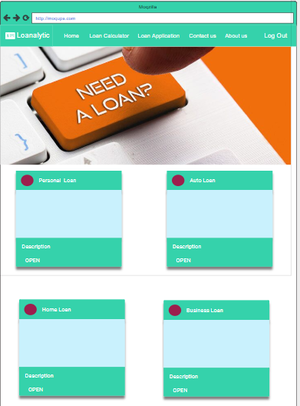

Admin Home:-

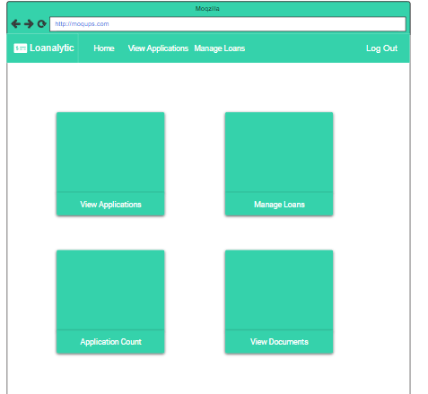

Manage Loans:-

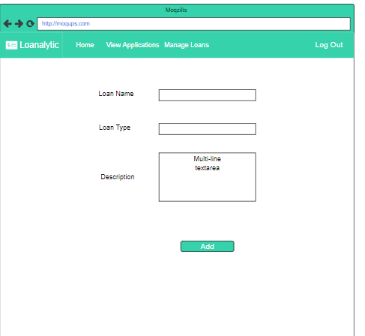

Contact Us :-

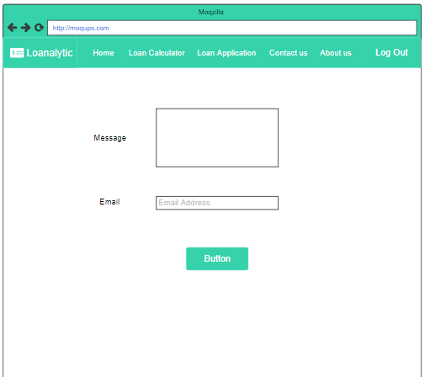

Loans:-

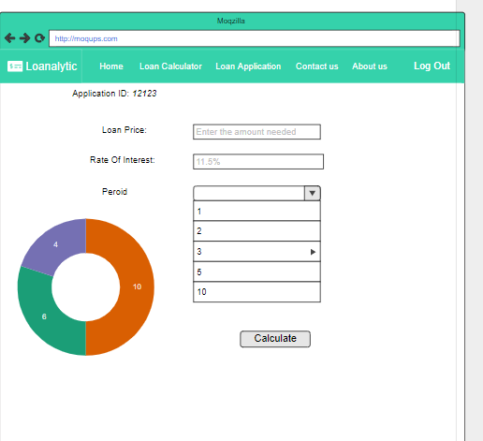

Loan Application:-

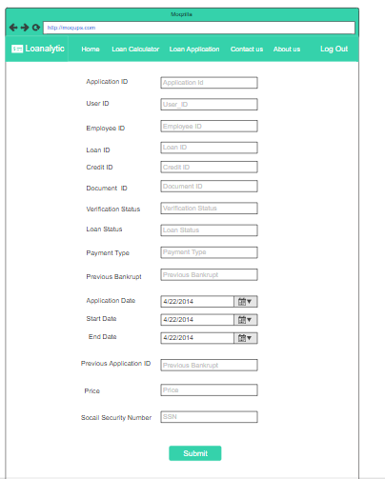

Loan Documents:-

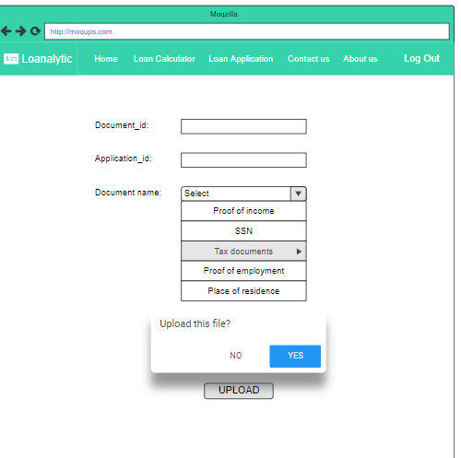

Credit Score:-

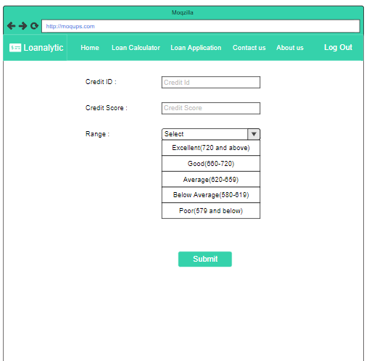

**3.11 Use Case Diagrams**

1. **Design**

**4.1 ER diagram:**

The major features of Loanalytic database system as shown in the below diagram.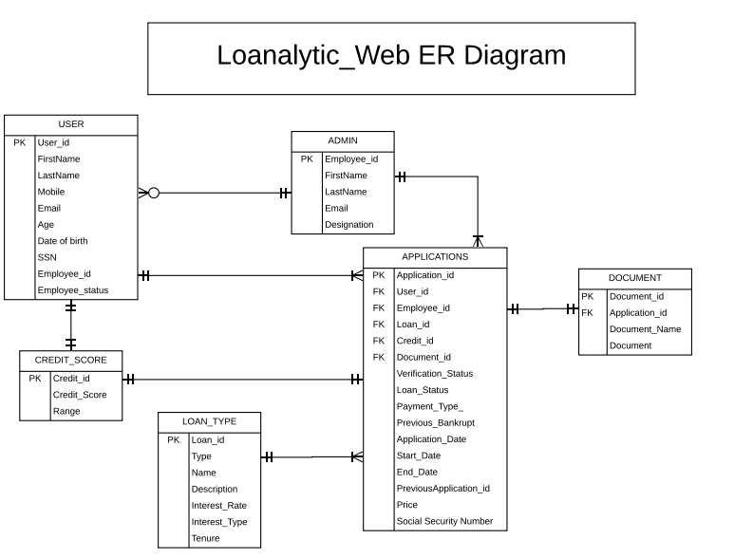

Fig 4.1

Fig 4.1 gives a complete description of all the entities used in the application. The description of each entity and the relation between them is specified below:

**USER:**

The user entity has all the attributes to store the information related to the user. It stores the information provided by the user during the registration phase.

**ADMIN:**

The admin entity stores the details related to the employees working for the application. The attributes include the employee id, first name, last name, email and designation.

**DOCUMENT:**

Document entity stores the required documents uploaded by the user and later the admin can view these documents.

**APPLICATIONS:**

Application table has all the information related to the application.

**LOAN TYPE:**

Loan type is a master table, it has all the in information related to loans. Admin can introduce new loans into the system through the interface.

**CREDIT SCORE:**

Credit score is a master entity, it stores the basic information of Credit score and the range associated with it.

**4.2 GUI**

1. **Analysis Models**

**5.1 Data Flow Diagram**

**5.2 Sequence Diagram**